Object Oriented Programming

Semester Project

UML Design

**Group Members:**

* Moonis Amir Zaman (365753)
* Muhammad Bilal Khan (380046)

**Project Task:**

* Bomberman Game

**Use Case Diagram**

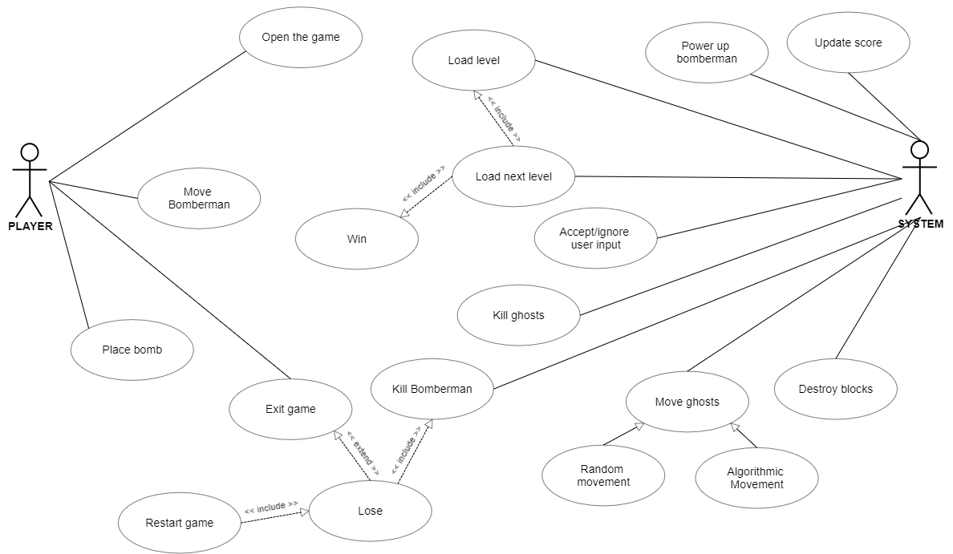

**Activity Diagram**

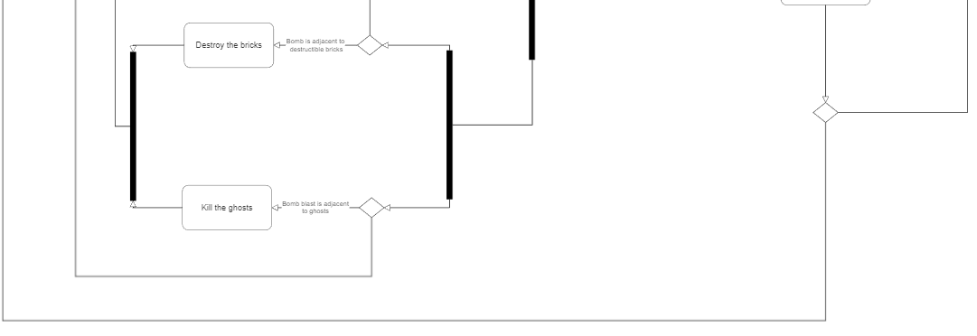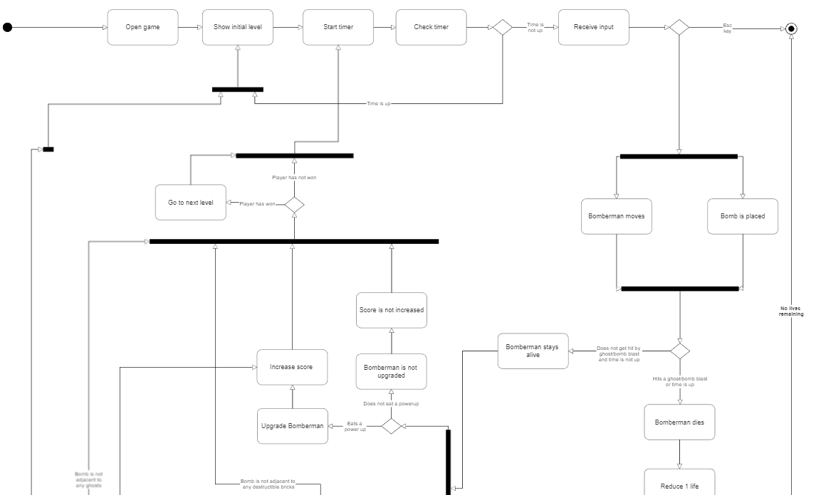

**Class Diagram**

**

**Sequence Diagram**



